Creating Quests

Introduction
With the release of EVB 2.5 comes a more dynamic quest system which allows for much more customisation.

Commands
The first things you need to know are the commands we’ll be using. You can either use the central game editor, /editgame, or the following commands:
- /editquest – Opens up the quest editor.
- /editconv – Opens up the conversation editor.
- /editnpc – Opens up the NPC editor.

Creating the Quest
The first thing we’re going to do is open up the quest editor (see above) and start working on our quest.
The most important part of this stage are the objectives:
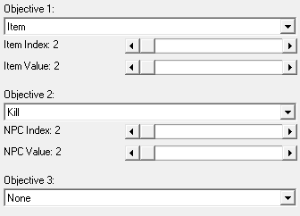
Objectives are parts of quests. All quest objectives need to be completed in order to complete a quest.

Creating the Conversation
The next thing you should do is work on the conversation. You do this by opening up the conversation editor whilst also keeping in mind three things:
- The quest start chat: This is the part of the chat that will allow players to accept or decline the NPC’s quest.
- The quest in-progress & quest finish chat: This chat will check whether or not the player has finished the quest by giving them the option to hand in the quest. That chat then leads onto the quest finish chat where you tell the player about the rewards they’ve earned.
- The post-quest chat: This is what the NPC says to the player after they’ve completed the quest and received their reward.
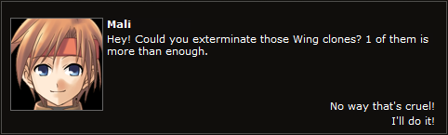

Creating the NPC
The final part in creating a quest is the actual quest giver. Simply open up the NPC editor and start creating your desired quest giver. Make sure they have at least 1 health point and the “quest giver” checkbox is checked.
You’ll also need to fill out the “Quest Data” panel using the conversation you created in the previous stage:
